

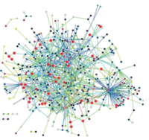 **Insilico System Biology Practical**

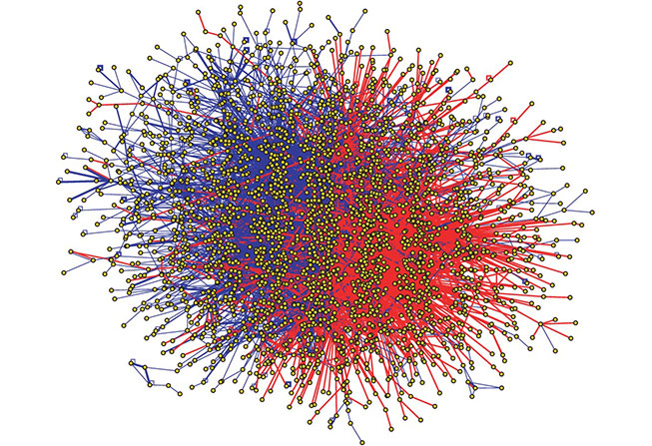

**Submitted by: Subhadeep Basu, Enrollment no: A9500320010**

**First year M.Sc. Bioinformatics Amity University Noida**

**Batch 2020-2022**

**EXPERIMENT - 13**

**Aim-** To explore an E. coli GEM, human GEM and yeast GEM using Metabolic ATLAS

**Tools Used**- **METABOLIC ATLAS**

**URL-** <https://www.metabolicatlas.org/>

**Theory-** Metabolic Atlas allows users to visualize the content of the integrated [Genome-scale metabolic models (GEMs)](https://metabolicatlas.org/documentation#Integrated-models) by using the [GEM browser](https://metabolicatlas.org/documentation#GEM-Browser) tool, and enables navigation of the metabolic network maps via the [Map viewer](https://metabolicatlas.org/documentation#Map-Viewer) tool. These two tools are available upon selecting one of the integrated models. The selected model is indicated to the right of the Metabolic Atlas logo in the top navigation bar. Leaving the Explore section (or the GEM Browser / Map Viewer tools) will unselect the model, and remove its name from the navigation bar.

To browse our integrated GEMs, visit the [GEM Repository](https://metabolicatlas.org/gems/repository) page.

The GEM Browser and the Map Viewer are closely connected, and users can navigate between the two tools using the buttons in the top navigation bar.

**Exploring the browser-**

1. Open GEM repository

Here you can see for human GEM there are two parts namely:

* GEM browser
* Map viewer

GEM BROWSER

The *GEM Browser* is a set of dedicated pages for different components of the model; reactions, metabolites, genes, subsystems, and compartments.

MAP VIEWER

The *Map Viewer* is a separate and independent interface, accessible after an integrated model has been selected. It includes a 2D viewer to vizualize metabolic maps in SVG format, and a 3D viewer to explore the metabolic network in 3 dimensions. Users can easly toggle between the *GEM Browser* and *Map Viewer* using the buttons in the top navigation bar.

To switch between 2D maps and 3D network, use the "Switch to 2D" or "Switch to 3D" button in the top left of the map, respectively. This button is disabled for a model without 2D maps, or when the corresponding 2D version of a 3D network is not available. The two left sidebar buttons are used to select which compartment or subsystem will be shown in the viewer.

1. Now open human GEM browser

In the above page you can see the following:

**GEM Browser**

**Reaction page**

This page shows information about the current selected reaction. If available, a list of references (PMIDs) is also shown in the Reference table below.

On the right of the page, a list of maps/networks where this reaction can be vizualize is displayed. Clicking on a map name will redirect the user to the *Map Viewer* tool; to return back to the *GEM Browser*, click the *GEM Browser* button in the top navigation bar.

**Metabolite page**

The Metabolite page shows information on the current selected metabolite. Metabolites in GEMs are often differentiated according to their cell compartment localization (e.g., endoplasmic reticulum). For this reason, one metabolic species, e.g. cholesterol, may correspond to several different metabolite entries in a GEM, such as cholesterol[c], cholesterol[m], etc. (the suffix indicates the compartment in which the metabolite is localized).

The top table contains basic information extracted from the GEM. If provided, several additional identifiers from external databases will be shown in the External IDs table below.

On the right side of the page, users can access the [Interaction Partners](https://metabolicatlas.org/documentation#Interaction-Partners) tool for the metabolite.

**Reactions table**

Lists all the reactions involving the current metabolite as a reactant or a product. The current metabolite is denoted with a black text color in the reaction equations. Since metabolites are specific to a cell compartment, only reactions involving the metabolite in its specific compartment are displayed. To remove this restriction and display additional reactions involving the metabolite in any compartment, click the *Expand to all compartments* button.

Note that the number of reactions is limited to 200; to retrieve all the reactions we invite users to use the [API](https://metabolicatlas.org/documentation#API).

**Gene page**

Shows information about the current selected gene. The top table contains basic information extracted from the GEM. If provided, several additional identifiers from external databases will be shown in the external IDs table.

On the right side of the page, users can access the [Interaction Partners](https://metabolicatlas.org/documentation#Interaction-Partners) tool for this gene.

**Reactions table**

Lists all the reactions catalyzed by the enzyme encoded by the current gene.

Note that the number of reactions is limited to 200; to retrieve all the reactions we invite users to use the [API](https://metabolicatlas.org/documentation#API).

**Subsystem page**

This page shows information on the current selected metabolic subsystem. Subsystems correspond to a set of reactions that share a similar metabolic function. Unlike a metabolic pathway, the reactions comprising a subsystem are not necessarily linked into a completely connected network.

A list of metabolites and genes contained within the current subsystem are shown in the table, but are restricted to a maximum of 1000 for each category. Use the [API](https://metabolicatlas.org/documentation#API) to retrieve the complete set of metabolites and genes for the selected subsystem.

**Reactions table**

Shows all the reactions that belong to the current subsystem. Note that in some GEMs, a given reaction can be associated with multiple subsystems. The number of reactions shown is limited to 1000; to retrieve all associated reactions we invite users to use the [API](https://metabolicatlas.org/documentation#API).

**Compartment page**

Shows information on the current selected compartment. The full list of metabolites, genes and reactions is available through the [API](https://metabolicatlas.org/documentation#API).

**Search**

Search for any term in metabolites, genes, reactions, subsystems, or compartments information.

The search is restricted to the selected GEM and limited to 50 results per type. Alternatively, users can click on the banner under the search input field to run a *Global Search*, where the term is searched among all the integrated models' components and is unrestricted. To learn more about the search term possiblities, go to the [Global Search](https://metabolicatlas.org/documentation#Global-Search) section of this page.

1. Go back to previous page and click on human GEM map viewer

In the above page you can see the following:

**Map Viewer**

**2D Viewer**

2D SVG maps are provided for integrated GEMs. They represent either a cell compartment or a subsystem/pathway. While a very high percentage of the reactions in the model are represented on the 2D maps, some may be unavailable.

Three buttons on the top left of the UI allow users to zoom in, zoom out and show/hide the genes on the current map.

Users can interact with the maps by clicking and dragging the mouse to pan the view or using the mouse wheel to zoom in/out.

A search function is available for 2D maps using the search bar. The window will zoom and center on each component found. Click the 'highlight' button to color all found components on the maps in red. To remove the highlight, simply clear the search bar.

The SVGs are interactive; click on a node (metabolite, reaction, gene) or a subsystem to load some of its information in the sidebar. Additonal information on the corresponding selected element can be accessed by clicking the *GEM browser* button.

**3D Viewer**

3D renderings of the metabolic network are automatically generated from the GEM data. This 3D graph contains all the reactions in the model, grouped by cellular compartment or subsystem.

Interaction with the 3D graph is possible using the mouse by holding left-click and moving the mose to rotate the view, right-click to pan, and use the mouse wheel to zoom in/out.

Users can also hover a node to view its name/id or left-clik on a node (once the graph has stopped moving) to display some of its information in the sidebar. Additonal information on the corresponding selected element can be accessed by clicking the *GEM browser* button.

**Data overlay**

Gene expression levels for genes from [The Human Protein Atlas v18](https://www.proteinatlas.org/about/releases#18) can be loaded using the *Data overlay* sidebar on the right side. Once selected, the RNA levels corresponding to the chosen tissue will be used to color each gene on the respective map, as shown in the legend. To clear the RNA levels, select the *None* option. RNA levels are available for both the 2D and 3D Map Viewer. The data is obtained from version 18 of the Protein Atlas with the units in log2(TPM+1) associated with a gradient colorbar.

The *Data overlay* sidebar allows for the upload of user-generated data in TSV format. If the file is parsed correctly, the file name will be highlighted green; in case errors are detected, it will be highlighted red. The expected format is at least two columns with headers using tab delimiters. For an exact description of the TSV file format [see the Wiki page](https://en.wikipedia.org/wiki/Tab-separated_values). The first column has to contain the gene IDs, identical to the ones in the model. Any missing genes or missing values will be assigned an "n/a" value and highlighted in gray. The rest of the columns act as data series, with each column being a new series, as shown in the example to the right. The headers of these data series will be shown automatically in the dropdown options for the uploaded data. The values are expected in TPM.

If multiple data are selected in the *Data overlay* sidebar, the overlay will switch to the comparison mode, using a differently colored legend for the log fold change between the selected data.

1. Going back to previous page now open Zebrafish GEM browser

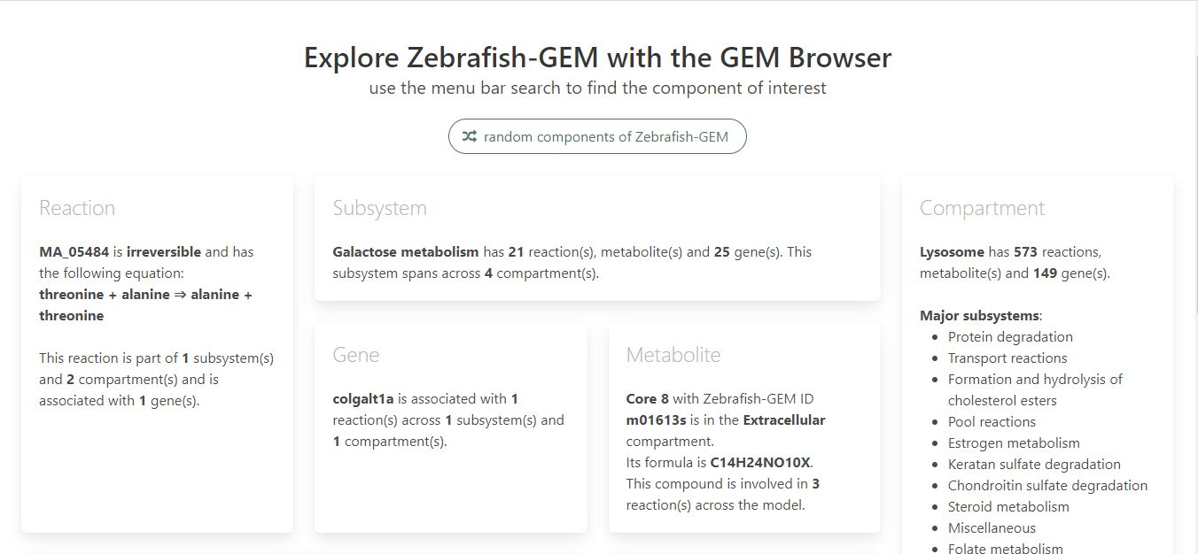

5. Open Zebrafish map viewer

